In this project, I developed a model to assist with business development for the Big Mountain ski resort in Montana. The main question being asked was: what changes to the resort would yield a significant increase in revenue? In order to best answer this data was pooled from all ski resorts across the US to investigate what factors best predicted ticket prices. Unfortunately, not all resorts made their ticket prices publicly available, nor did all resorts have readily available information on their facilities. Ticket price was able to be estimated by substituting in median prices of other resorts in that region, but other information wasn’t so easily estimated.

One of the first questions investigated was whether or not state was a valid predictor for ticket price. In order to investigate this, a standard correlation test and linear regression were both employed. State was found not to be a significant predictor variable, but it was kept in the final analysis in order to better organize and present the data. Following this, other potential predictor variables were tested using two regressions: a linear regression and a random forest regression model each sampling 70% of the data and tested against the remaining 30%. The random forest model proved to be a more accurate predictor. The model was saved and exported to be used again, and would be available to the business development team at Big Mountain ski resort for any future questions of business development.

Employing the random forest model across all data, I found the best predictor variables for ticket price were: vertical drop, snow making (acres), total chairs, fast quad lifts, total number of runs, the length of the longest run (miles), total number of trams, and total skiable terrain (acres). Incorporating these variables into the model, I then tested what the effects of making adjustments to each variable would be on ticket price. Ultimately, I found that the best way to increase ticket prices was to add an additional run and associated chair lift at the bottom of the mountain that extended 150 feet below the current base of the resort. Increasing snow making, or the length of the longest run didn’t yield an increase in ticket value. Another avenue to increase overall revenue that could be pursued would be to reduce the total number of runs at the resort by 6 or 8. These values are selected as they happen to be at the edge of ‘plateaus’ where ticket value will decrease with another run lost. I would recommend to the business development team to close 6 and 8 of the least used runs alternately for a one month period over the course of a ski season and calculate the total revenue accrued by lack of maintenance and chair lift operations. Then compare this additional revenue against the predicted ticket value decrease by losing the runs.

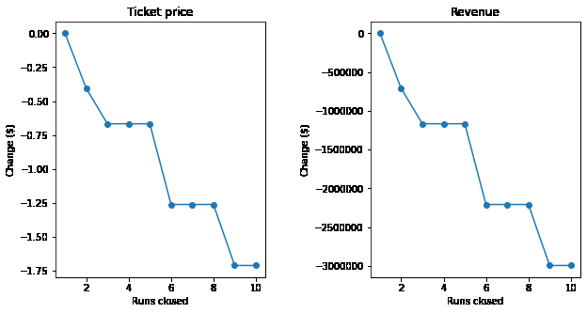

Figure 1: Ticket price and Revenue compared with total number of runs closed.